The laboratory work 5

Update the app with Visual Studio
- Launch Visual Studio and open the Notes solution.
- In Solution Explorer, select the Notes project, right-click and select Manage NuGet Packages...:
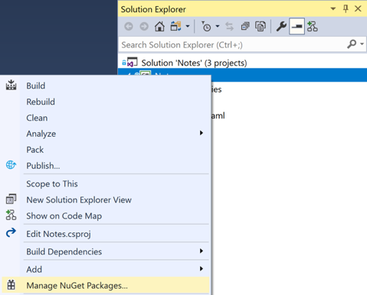
- In the NuGet Package Manager, select the Browse tab, search for the sqlite-net-pcl NuGet package, select it, and click the Install button to add it to the project:
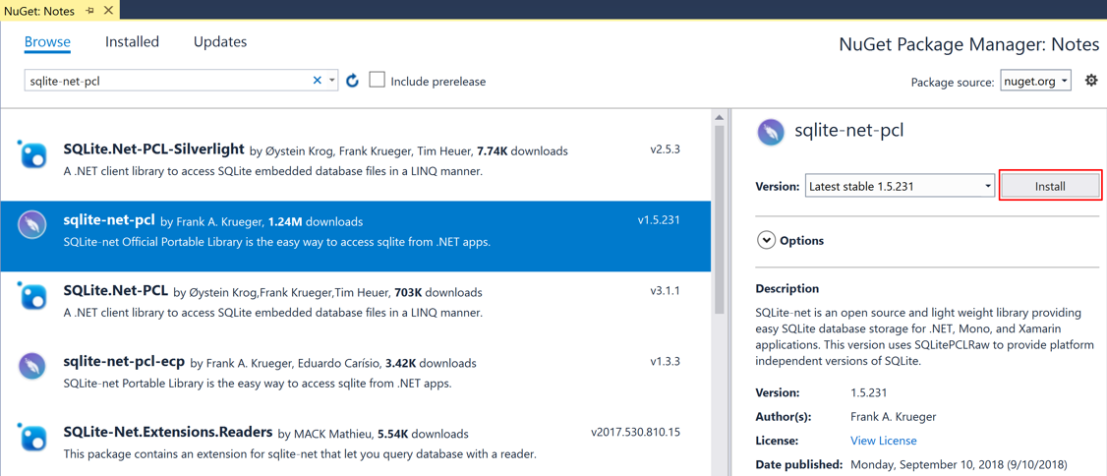

- In Solution Explorer, in the Notes project, open Note.cs in the Models folder and replace the existing code with the following code:
using System;
using SQLite;

namespace Notes.Models
{
public class Note
{
[PrimaryKey, AutoIncrement]
public int ID {get; set;}
public string Text {get; set;}
public DateTime Date {get; set;}
}
}
This class defines a Note model that will store data about each note in the application. The ID property is marked with PrimaryKey and AutoIncrement attributes to ensure that each Note instance in the SQLite.NET database will have a unique id provided by SQLite.NET.
Save the changes to Note.cs by pressing CTRL+S, and close the file.
- In Solution Explorer, add a new folder named Data to the Notes project.
- In Solution Explorer, in the Notes project, add a new class named NoteDatabase to the Data folder.
- In NoteDatabase.cs, replace the existing code with the following code:
using System.Collections.Generic;
using System.Threading.Tasks;
using SQLite;
using Notes.Models;
namespace Notes.Data
{
public class NoteDatabase
{
readonly SQLiteAsyncConnection _database;
public NoteDatabase(string dbPath)
{
_database = new SQLiteAsyncConnection(dbPath);
_database.CreateTableAsync<Note>().Wait();
}

public Task<List<Note>> GetNotesAsync()
{
return _database.Table<Note>().ToListAsync();
}

public Task<Note> GetNoteAsync(int id)
{
return _database.Table<Note>()
.Where(i => i.ID == id)
.FirstOrDefaultAsync();
}
public Task<int> SaveNoteAsync(Note note)
{
if (note.ID != 0)
{
return _database.UpdateAsync(note);
}
else
{
return _database.InsertAsync(note);
}
}

public Task<int> DeleteNoteAsync(Note note)
{
return _database.DeleteAsync(note);
}
}
}
This class contains code to create the database, read data from it, write data to it, and delete data from it. The code uses asynchronous SQLite.NET APIs that move database operations to background threads. In addition, the NoteDatabase constructor takes the path of the database file as an argument. This path will be provided by the App class in the next step.
Save the changes to NoteDatabase.cs by pressing CTRL+S, and close the file.
- In Solution Explorer, in the Notes project, double-click App.xaml.cs to open it. Then replace the existing code with the following code:
using System;
using System.IO;
using Xamarin.Forms;
using Notes.Data;

namespace Notes
{
public partial class App: Application
{
static NoteDatabase database;

public static NoteDatabase Database
{
get
{
if (database == null)
{
database = new NoteDatabase(Path.Combine(Environment.GetFolderPath(Environment.SpecialFolder.LocalApplicationData), "Notes.db3"));
}
return database;
}
}

public App()
{
InitializeComponent();
MainPage = new NavigationPage(new NotesPage());
}

protected override void OnStart()
{
// Handle when your app starts
}

protected override void OnSleep()
{
// Handle when your app sleeps
}

protected override void OnResume()
{
// Handle when your app resumes
}
}
}
This code defines a Database property that creates a new NoteDatabase instance as a singleton, passing in the filename of the database as the argument to the NoteDatabase constructor. The advantage of exposing the database as a singleton is that a single database connection is created that's kept open while the application runs, therefore avoiding the expense of opening and closing the database file each time a database operation is performed.
Save the changes to App.xaml.cs by pressing CTRL+S, and close the file.
- In Solution Explorer, in the Notes project, double-click NotesPage.xaml.cs to open it. Then replace the OnAppearing method with the following code:
protected override async void OnAppearing()
{
base.OnAppearing();

listView.ItemsSource = await App.Database.GetNotesAsync();
}
- In Solution Explorer, double-click NoteEntryPage.xaml.cs to open it. Then replace the OnSaveButtonClicked and OnDeleteButtonClicked methods with the following code:
async void OnSaveButtonClicked(object sender, EventArgs e)
{
var note = (Note)BindingContext;
note.Date = DateTime.UtcNow;
await App.Database.SaveNoteAsync(note);
await Navigation.PopAsync();
}

async void OnDeleteButtonClicked(object sender, EventArgs e)
{
var note = (Note)BindingContext;
await App.Database.DeleteNoteAsync(note);
await Navigation.PopAsync();
}
The NoteEntryPage stores a Note instance, which represents a single note, in the BindingContext of the page. When the OnSaveButtonClicked event handler is executed, the Note instance is saved to the database and the application navigates back to the previous page. When the OnDeleteButtonClicked event handler is executed, the Note instance is deleted from the database and the application navigates back to the previous page.
Save the changes to NoteEntryPage.xaml.cs by pressing CTRL+S, and close the file.
- Build and run the project on each platform. For more information, see Building the quickstart.
On the NotesPage press the + button to navigate to the NoteEntryPage and enter a note. After saving the note the application will navigate back to the NotesPage.
Enter a number of notes, of varying length, to observe the application behavior.

